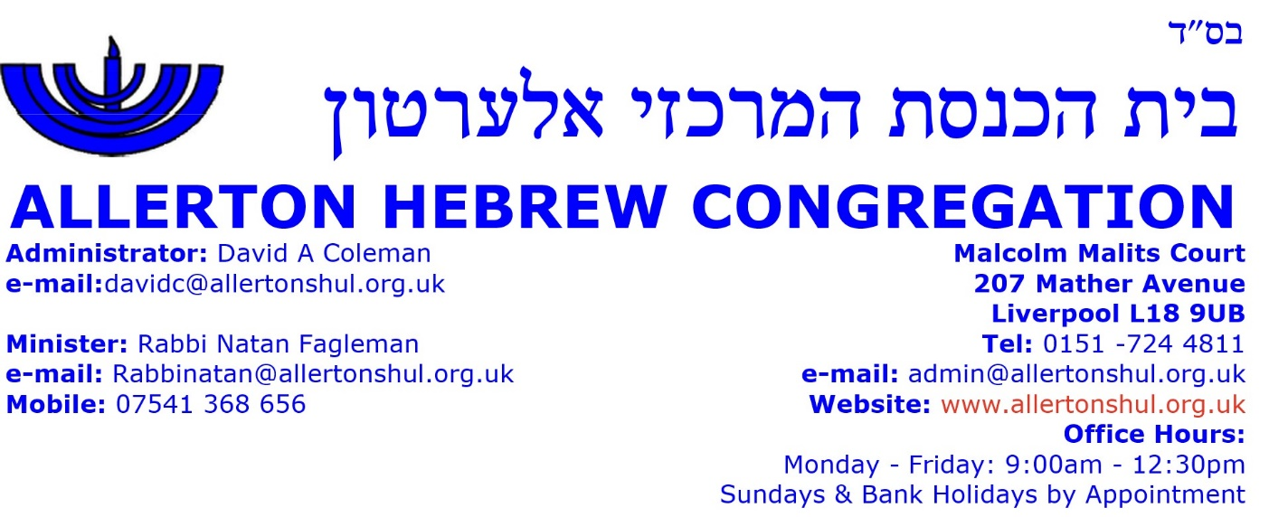

SYNAGOGUE TOUR BOOKING FORM

SCHOOL / GROUP NAME: Click or tap here to enter text.
ADDRESS: Click or tap here to enter text.

GROUP CONTACT NAME: Click or tap here to enter text.
TELEPHONE: Click or tap here to enter text.
GROUP DETAILS: -
NUMBER IN GROUP: Click or tap here to enter text.
AGE: Click or tap here to enter text.
DATE OF TOUR: Click or tap here to enter text.
FEE: £120 per group plus Challah - £Click or tap here to enter text.

=========================================================================================

INVOICE / REMITTANCE
NAME: Click or tap here to enter text.
ADDRESS: Click or tap here to enter text.
CHARGE: Click or tap here to enter text.

CHEQUES SHOULD BE MADE PAYABLE TO “ALLERTON HEBREW CONGREGATION”
PAYMENT MAY BE MADE BY BACS TO SORT CODE: 20-50-82 ACCOUNT No.: 80111244

Synagogue tours may comprise some, but not all, of the following basic subjects:
Approx. 20 minutes
Approx. 25 minutes
Approx. 15 minutes
☐ Introduction to Judaism
☐ How monotheism began – Abraham, Isaac & Jacob
☐ Children of Israel in Egypt & the Exodus
☐ Torah
☐ The Synagogue & Jewish Artefacts
Approx. 25 minutes
Approx. 20 minutes
Approx. 20 minutes
☐ Description of the Sabbath Day (Shabbat)
☐ The Jewish Year & Festivals
☐ Taste of Challah Bread for each participant if requested (£6 extra)
(May contain trace of nuts)
☐ Any other subject requests, please list below

Please tick the boxes of those subjects to be covered over the 90 minutes
N.B.: Timings are approximate and may depend upon the Speaker, Students participation and questions.

For Office Use:
Speaker: Name of Speaker
Invoice Amount: Invoice Amount Invoice Paid: ☐

